## Birdhouse

## Notice and Wonder: For the Birds

What do you notice? What do you wonder?

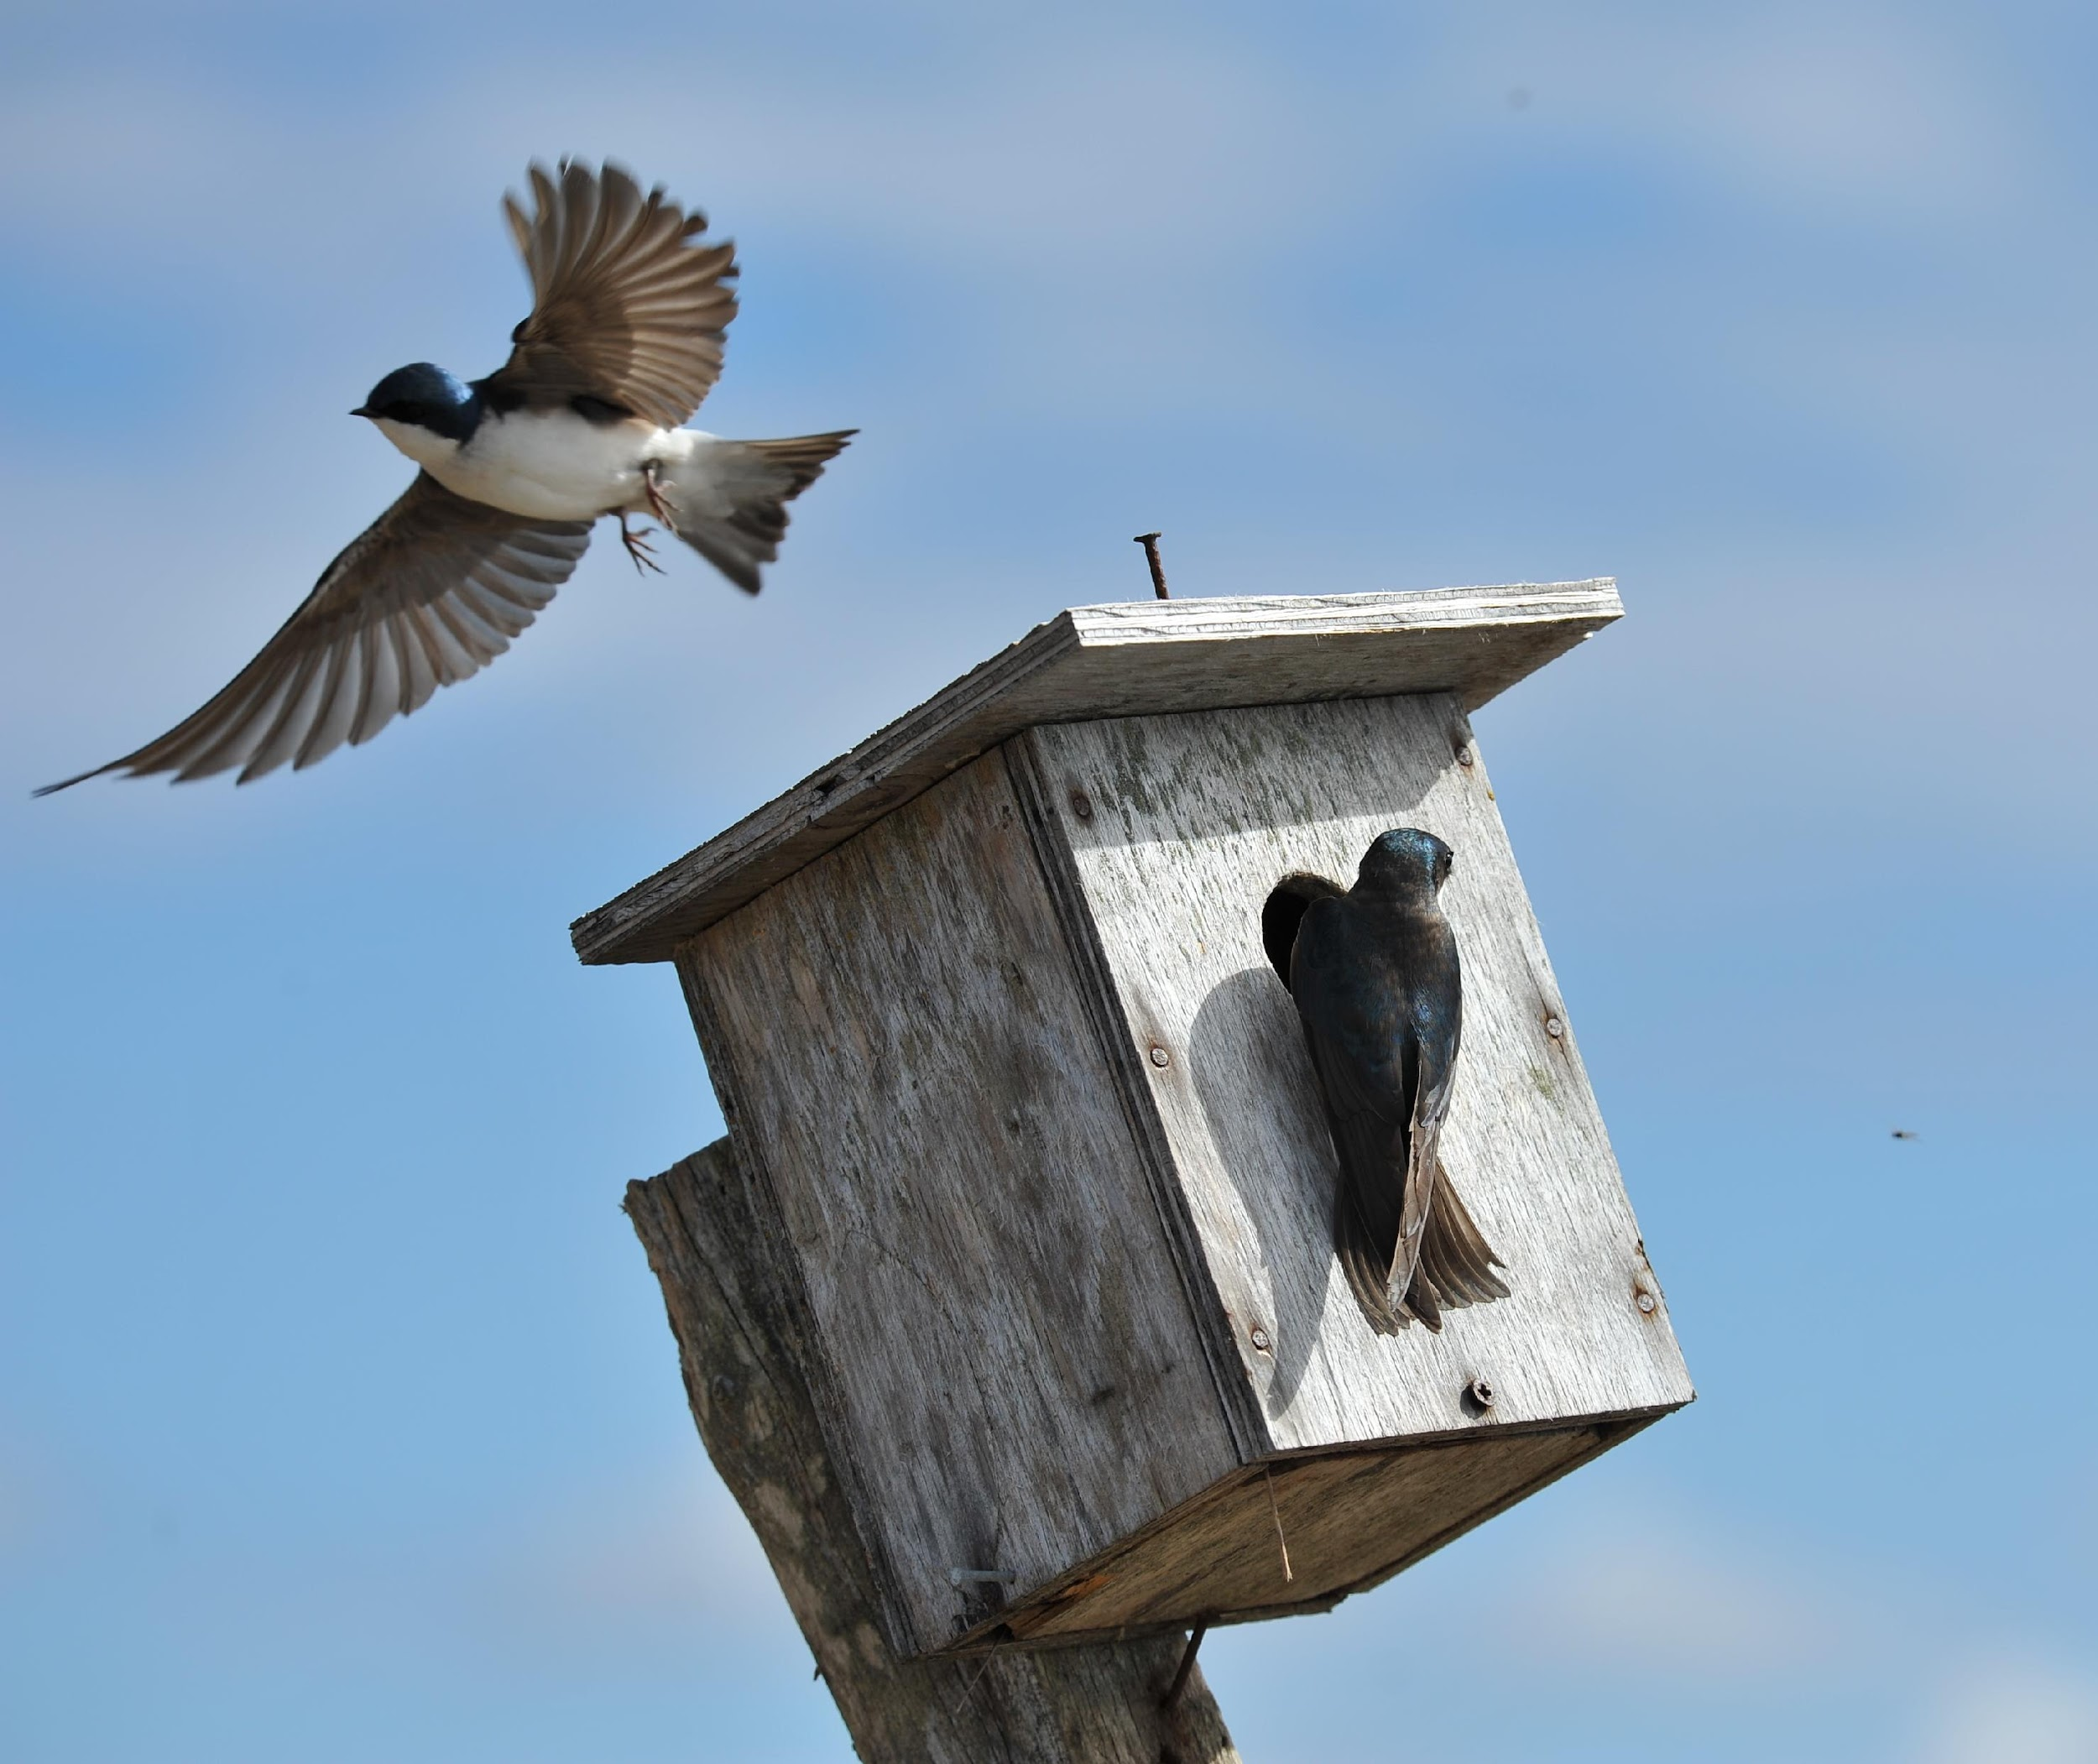

| Notice | Wonder |
| --- | --- |
|  |  |

### What is the Volume?

Use the criteria from the table to determine the recommended range of volumes for each type of birdhouse.

| **type of bird** | **dimensions of the floor** | **height** | **range of volume** |
| --- | --- | --- | --- |
| **chickadee** | 4 in by 4 in | 6 to 10 in |  |
| **swallow** | 6 in by 6 in | 6 to 8 in |  |
| **bluebird** | 5 in by 5 in | 6 to 12 in |  |
| **red-headed woodpecker** | 6 in by 6 in | 12 to 15 in |  |
| **wood duck** | 10 in by 18 in | 10 to 24 in |  |
| **barn owl** | 10 in by 18 in | 15 to 18 in |  |